WMHA has developed the **Future Wolves** program to make player's first contact with hockey a fun, safe and positive experience. It's a structured, learn-to-play hockey program designed to introduce beginners to the game's basic skills. It enables participants to become contributing members of a team effort, develop self-confidence, and experience a sense of personal achievement. These goals are achieved in an atmosphere of fun and fair play.

**NEW** this year will be an element of full ice Power Skating, lead by Waterloo’s own Haley Loveday. Coupled with the Skills & Drills teaching of Eric Calder, this program is sure to be BEST IN CLASS, not to mention an incredible value proposition.

**THE PROGRAM - REVISED!!**

**PROGRAM HIGHLIGHTS**

* Structured age and ability appropriate program
* Safe, FUN and comfortable learning environment
* All levels of skill and ability WELCOME!
* Experienced coaching staff
* LOWEST FEES IN WATERLOO REGION
* All players receive a FUTURE WOLVES jersey & socks
* SPECIAL EVENTS, including field trips, tournaments

**PROFESSIONAL INSTRUCTION**

**ERIC CALDER, Technical Director**

* Certified NCCP High Performance 2 Coach with NCCP Level 3 Theory from Hockey Canada
* One of the most sought-after instructors in the KW area
* 20+ years of Professional, European, Canadian University, Junior B and Minor Hockey coaching experience
* Club European Cup Finalist, CIAU All-Canadian, Memorial Cup Champion (Cornwall), and Canadian MVP of World Junior Championships
* Waterloo Minor Hockey Alumnus

**HAYLEY LOVEDAY, Power Skating Instructor**

* Trained by Brigette Wolfe
* Ontario Certified Teacher
* Worked with Guelph, Fergus, Waterloo Ringette Assoc’s.

**WMHA PHYLOSOPHY**

***A single 60 min cross-ice hockey practice will give players more puck touches than 180 full ice games!!***

The **Future Wolves** gives players the chance to learn fundamental movement and fundamental sport skills in a quality sport program tailored just for them.

The program maximizes ice utilization through the use of **Teaching Stations and Cross-Ice Games.** More puck touches means more skill development and more fun!

**In the Cross-Ice environment, a player's activity increases and so does their skill set and love of the game!**

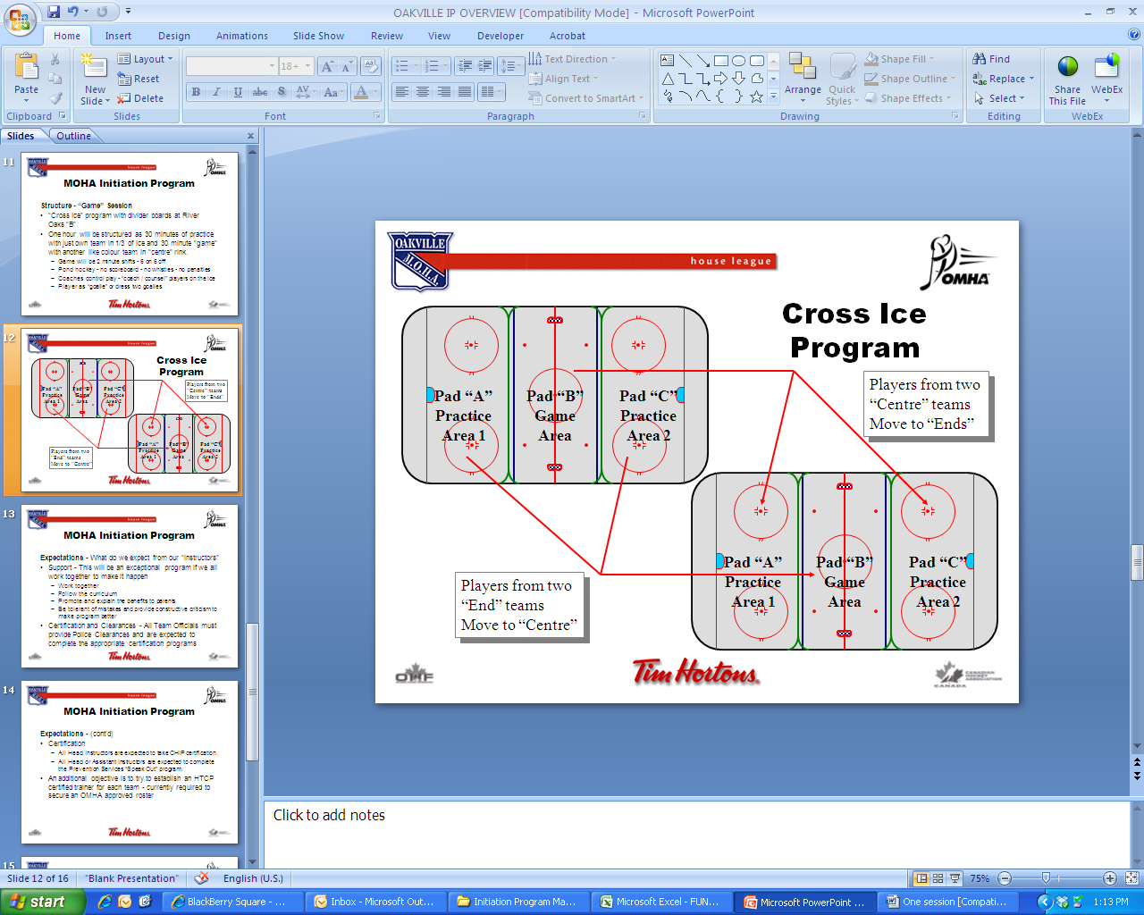

**THE FUNDAMENTALS GROUP**

**Initiation Division** (ages 4 & 5)

Fridays (5:00-8:00pm) Saturdays (10:00am-12:00pm)

**Pre-Tyke** (age 6)

Wednesdays (5:00-8:00pm) Saturdays (7:00-10:00am)

**Tyke** (age 7) – Every 3rd Wednesday (4-5pm) Game Day

Fridays (5:30-8:30pm) Sundays (7:00-10:00am)

**2015-16 Season**



***F U T U R E***

**INITIATION • PRE-TYKE • TYKE**



WHERE THE

FUN BEGINS!

**WATERLOO MINOR HOCKEY ASSOCIATION**

**(519) 725-1434**

**waterloominorhockey.com**



**4 & 5 Year Old Program**

**ICE TIME**

* **NEW**! 2 Ice Times per week
* Fridays 5:00-8:00 pm
* Saturdays 10:00am – 1pm

**PRACTICE FORMAT**

* Full-ice practices using integrated station approach with structured skill development
* Common structured age and ability appropriate program across groups developed by WMHA and Eric Calder (Skills Plus)
* **NEW!** Full-ice Power Skating Sessions during the season by Hayley Loveday.

**CURRICULUM**

The Future Wolves **Initiation Division** is a fun way to develop skills as well as a love for the game of hockey!

Future hockey stars will learn and develop their hockey skills with structured age and ability appropriate games and skill specific stations emphasizing fun!

The program that focuses on getting players to be comfortable on the ice, learn the basic hockey stance, stride, knee bend, use of edges and how to hold a stick before moving into a more full hockey curriculum.

Once basic balance and skating skills have been learned, the program progresses to developing puck related skills and fun games such as cross-ice pond hockey.



**Pre-Tyke 6 Year Old Program**

**ICE TIME**

* Wednesdays 5:00-8:00pm
* Saturdays 7:00-10:00am
* **NEW!** Rostered Tournament Teams
* **NEW!** Exhibition Games

**PRACTICE FORMAT**

* Full-ice practices using integrated station approach with structured skill development program across groups developed by WMHA and Eric Calder (Skills Plus)
* Combined practice/game session taking advantage of the efficiencies of a **“Cross Ice”** format, special rink dividers and the Olympic size RIM Park ice surface
* **NEW!** Full-ice Power Skating Sessions during the season by Hayley Loveday.

**CURRICULUM**

The Future Wolves **Pre-Tyke Division** allows players to further develop and refine their basic hockey skills as well as get introduced to the fun and excitement of playing the game!

As a **“skills-focused”** program with continued focus on skating skills in combination with puck handling, shooting and passing. Gradual exposure to full-ice hockey, including individual and team tactics.

**NEW!** **Full Game Exposure:** WMHA will roster players and enter teams in 1-2 Tournaments plus Exhibition Games; may cost extra.



**Tyke 7 Year Old Program**

**ICE TIME**

* Fridays 5:30-8:30pm
* Sundays 7:00-10:00am
* Wednesdays 4-5pm (Every 3rd Week)*
* **NEW!** Rostered Tournament Teams
* **NEW!** Exhibition Games
* **NEW!** *Full Ice Inter-squad Games

**PRACTICE FORMAT**

* Full-ice practices using integrated station approach with structured skill development program across groups developed by WMHA and Eric Calder (Skills Plus)
* Combined practice/game session taking advantage of the efficiencies of a **“Cross Ice”** format, special rink dividers and the Olympic size RIM Park ice surface
* **NEW!** Full-ice Power Skating Sessions during the season by Hayley Loveday.

**CURRICULUM**

The Future Wolves **Tyke Division** continues to build on the skills learned in Pre-Tyke.

Advanced development of skating and hockey skills is the focus of this program as players are challenged to take their game to the next level in preparation for mainstream Novice hockey. Players will receive increased exposure to full-ice hockey, individual and team tactics.

**NEW!** **Full Game Exposure:** WMHA will roster players and enter teams in up to 2-3 Tournaments plus Exhibition Games: may cost extra.